Non - Linearity

1) Calculate the frequencies and power levels of all second and third order products

at the output of the amplifier shown below.

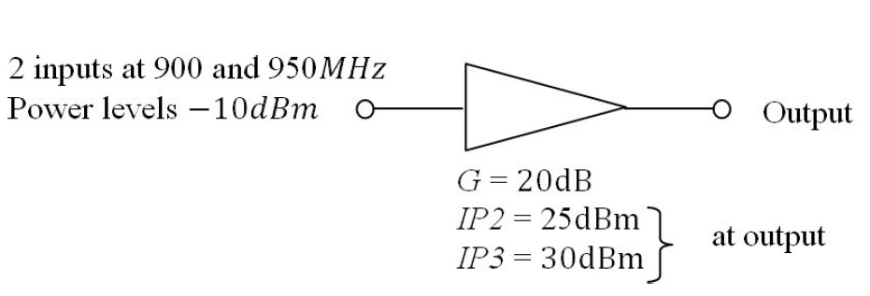

Calculations:

F1 = 0.9 GHz, F1 = 0.95 GHz

2nd order IM = F1 + F2 & F2 - F1 = 1.85 GHz, 0.05GHz

3rd order IM frequencies= 2F1 + F2 , F1 + 2F2 , 2F1 - F2 , 2F2 – F1 = 2.750 GHz, 2.8 GHz, 0.85 GHz, 1.0GHz

P0 = 10dB

IP2 = 25 dB

IP3 = 30 dB

OIP2 = 2P0 – IP2 = 2\* 10 – 25 = -5.0dB

OIP3 = 3P0 – 2IP3 = 3\* 10 – 2\*30 = -30.0 dB